
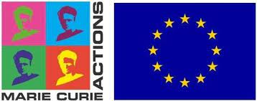

Application Form- ROOTED
Doctoral Network (DN)
Marie Skłodowska‐Curie Action
Call: HORIZON-MSCA-DN-2021

PERSONAL DATA
First Name
Family Name
Email Address
Postal Address
Country of Citizenship
Nationality
Gender

- COUNTRY OF RESIDENCE DURING THE LAST 3 YEARS
Please indicate your country of residence since 1st January 2020. This information is needed to determine if applicants fulfill the EU Mobility Rule for the position(s) applied for- Researchers must not have resided or carried out their main activity (e.g., work, studies) in the country of the recruiting beneficiary for more than 12 months in the 36 months immediately before their recruitment date.
Starting date | End date | Country

EDUCATION AND QUALIFICATIONS
Please indicate your degree qualifications below.

BACHELOR’S DEGREE
Institution/university
City, country
Major field of study
Start and end dates | mm/yy - mm/yy
Number of ECTS obtained
GPA

MASTER’S DEGREE
Institution/university
City, country
Major field of study
Start and end dates | mm/yy - mm/yy
Number of ECTS obtained
GPA

STATEMENT AND SIGNATURE

The data you provide will be used to process your application to the ROOTED Consortium, and to report aggregated statistics on the ROOTED recruitment process to the EU. The data will be kept for a period of five years after the end of the project for the purpose of an audit by the EU.

Printed name:

Location:

Date:

Signature:

